ULTRASONIC TESTING REPORT
Company/Client |  | NCOC N. V. |  | Project |  | ESKENE WEST |  | Location |  | KUT-570
Line No/Tag No: |  | A1-5700-CS-035-3/4"-NI2.4-HC |  | Material |  | Pipe:B167- N06600;  Elbow: B366 |  | Día × Nominal Thickness |  | ¾”×2.87mm
Procedure No: |  | QP-11-UTT-Q01 Rev 03  GOST 28702-90 |  | Calibration Block |  | Step wedge |  | Probe  S/N |  | D7908  1214571
 |  |  |  | Calibration block Range |  | 2.0-20.0 mm |  | Angle |  | 0º
Manufacturing Code |  | ASME B31.3 |  | Calibration Temp |  | +31ºC |  | Frequency |  | 7.5 MHz
 |  |  |  | Object Temp |  | +30ºC |  | Size |  | 5.1 mm
Acceptance Standard: |  | Acc. to the client specif. |  | Correction factors |  | n/a |  | Crystal |  | Dual
Surface condition |  | Uncoated |  | Couplant |  | UT Gel |  | Accuracy |  | ± 0,1 mm
S. No | Equipment/  Material Name |  | Manufacturer |  | Serial No |  | Calibration certificate No |  | Calibration Expiry date
 | DL-38 |  | OLYMPUS |  | 183107401 |  | BK-01-0079 |  | 05-02-2021
 | Step wedge calibration block |  | NDE-TECH |  | NDE-8365 |  | - |  | -
Job description:

- UT spot check performed on line A1-5700-CS-035-3/4"-NI2.4-HC (drawing No KE01-A1-570-MT-P-DI-1001-091).
- P&ID scheme No is KE01-A1-570-MT-R-HP-0024-008.
- Standard UT technique was used.
- Inspection performed on East, West, South, North, Top, Bottom and Extrados from external.
Notes:
N/A – not applicable.
FSH - Full Screen Height

Inspection drawing
KE01-A1-570-MT-P-D1-1001-091
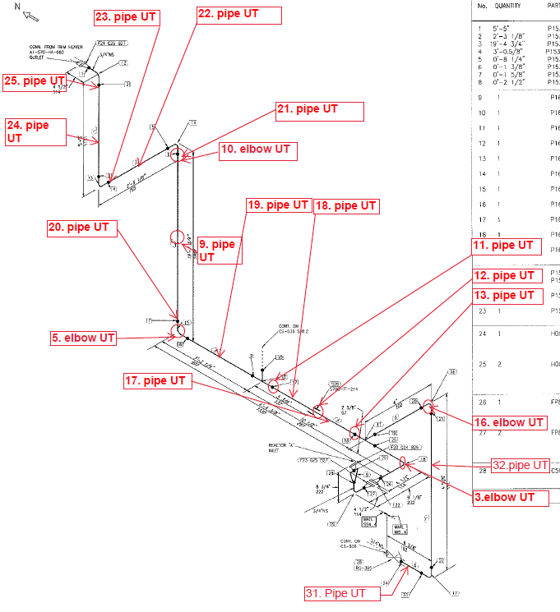

Inspection results
S/NO | P&ID | Isometric No | Line No | Item description | DIA(Ø), inch | Nominal thickness, mm* | East  mm | West  mm | South  mm | North  mm | Top  mm | Bottom  mm | Extrados  mm
1 | KE01-A1-570-MT-R-HP-0024-008 | KE01-A1-570-MT-P-DI-1001-091 | A1-5700-CS-035-3/4"-NI2.4-HC | Elbow -3 | ¾ | 2.87 | - | - | - | - | 2.68 | 2.58 | 2.41
2 | KE01-A1-570-MT-R-HP-0024-008 | KE01-A1-570-MT-P-DI-1001-091 | A1-5700-CS-035-3/4"-NI2.4-HC | Elbow -5 | ¾ | 2.87 | 2.55 | 2.59 | - | - | - | - | 2.31
3 | KE01-A1-570-MT-R-HP-0024-008 | KE01-A1-570-MT-P-DI-1001-091 | A1-5700-CS-035-3/4"-NI2.4-HC | Pipe -09 | ¾ | 2.78 | 2.81 | 2.78 | 2.98 | 2.74 | - | - | -
4 | KE01-A1-570-MT-R-HP-0024-008 | KE01-A1-570-MT-P-DI-1001-091 | A1-5700-CS-035-3/4"-NI2.4-HC | Elbow -10 | ¾ | 2.87 | - | - | 2.70 | 2.72 | - | - | 2.37
5 | KE01-A1-570-MT-R-HP-0024-008 | KE01-A1-570-MT-P-DI-1001-091 | A1-5700-CS-035-3/4"-NI2.4-HC | Pipe -11 | ¾ | 2.87 | 2.68 | 2.64 | - | - | 2.73 | 2.58 | -
6 | KE01-A1-570-MT-R-HP-0024-008 | KE01-A1-570-MT-P-DI-1001-091 | A1-5700-CS-035-3/4"-NI2.4-HC | Pipe -12 | ¾ | 2.87 | 2.63 | 2.68 | - | - | 2.74 | 2.65 | -
7 | KE01-A1-570-MT-R-HP-0024-008 | KE01-A1-570-MT-P-DI-1001-091 | A1-5700-CS-035-3/4"-NI2.4-HC | Pipe -13 | ¾ | 2.87 | 2.63 | 2.44 | - | - | 2.50 | 2.64 | -
8 | KE01-A1-570-MT-R-HP-0024-008 | KE01-A1-570-MT-P-DI-1001-091 | A1-5700-CS-035-3/4"-NI2.4-HC | Elbow -16 | ¾ | 2.87 | - | - | 2.84 | 2.63 | - | - | 2.57
9 | KE01-A1-570-MT-R-HP-0024-008 | KE01-A1-570-MT-P-DI-1001-091 | A1-5700-CS-035-3/4"-NI2.4-HC | Pipe -17 | ¾ | 2.87 | 2.79 | 2.75 | - | - | 2.79 | 2.80 | -
10 | KE01-A1-570-MT-R-HP-0024-008 | KE01-A1-570-MT-P-DI-1001-091 | A1-5700-CS-035-3/4"-NI2.4-HC | Pipe -18 | ¾ | 2.87 | 2.77 | 2.75 | - | - | 2.79 | 2.79 | -
11 | KE01-A1-570-MT-R-HP-0024-008 | KE01-A1-570-MT-P-DI-1001-091 | A1-5700-CS-035-3/4"-NI2.4-HC | Pipe -19 | ¾ | 2.87 | 2.42 | 2.41 | - | - | 2.42 | 2.38 | -
12 | KE01-A1-570-MT-R-HP-0024-008 | KE01-A1-570-MT-P-DI-1001-091 | A1-5700-CS-035-3/4"-NI2.4-HC | Pipe -20 | ¾ | 2.87 | 2.82 | 2.75 | 2.80 | 2.80 | - | - | -
13 | KE01-A1-570-MT-R-HP-0024-008 | KE01-A1-570-MT-P-DI-1001-091 | A1-5700-CS-035-3/4"-NI2.4-HC | Pipe -21 | ¾ | 2.87 | 2.74 | 2.74 | 2.82 | 2.76 | - | - | -
14 | KE01-A1-570-MT-R-HP-0024-008 | KE01-A1-570-MT-P-DI-1001-091 | A1-5700-CS-035-3/4"-NI2.4-HC | Pipe -22 | ¾ | 2.87 | - | - | 2.44 | 2.42 | 2.43 | 2.44 | -
15 | KE01-A1-570-MT-R-HP-0024-008 | KE01-A1-570-MT-P-DI-1001-091 | A1-5700-CS-035-3/4"-NI2.4-HC | Pipe -23 | ¾ | 2.87 | - | - | 2.22 | 2.28 | 2.24 | 2.22 | -
16 | KE01-A1-570-MT-R-HP-0024-008 | KE01-A1-570-MT-P-DI-1001-091 | A1-5700-CS-035-3/4"-NI2.4-HC | Pipe -24 | ¾ | 2.87 | 2.46 | 2.49 | 2.48 | 2.52 | - | - | -
17 | KE01-A1-570-MT-R-HP-0024-008 | KE01-A1-570-MT-P-DI-1001-091 | A1-5700-CS-035-3/4"-NI2.4-HC | Pipe -25 | ¾ | 2.87 | 2.17 | 2.23 | 2.18 | 2.25 | - | - | -
18 | KE01-A1-570-MT-R-HP-0024-008 | KE01-A1-570-MT-P-DI-1001-091 | A1-5700-CS-035-3/4"-NI2.4-HC | Pipe -31 | ¾ | 2.87 | 2.64 | 2.74 | - | - | 2.77 | 2.72 | -
19 | KE01-A1-570-MT-R-HP-0024-008 | KE01-A1-570-MT-P-DI-1001-091 | A1-5700-CS-035-3/4"-NI2.4-HC | Pipe -32 | ¾ | 2.87 | 2.64 | 2.68 | 2.74 | 2.56 | - | - | -

*according to ASME B36.10-B36.19 schedule 40

Examined by  UT L II cert. No. 811  exp. date 10.04.2022 | Name: Akhmadaliyev Roman | Signature: ............................... | Date: 10 Jun 2020
Approved by  UT L II cert. No 1A 167/17  expiry date 31.01.2022 | Name: Barsukou Raman | Signature: ........................... | Date: 10 Jun 2020
Client Representative: | Name: …………………………… | Signature: .............................. | Date: ………………………

